SIMATS ENGINEERING
ASSESSMENT TOOL 4

COURSE NAME: Artificial Intelligence COURSE CODE: CSA17

COURSE OUTCOME COVERED

CO2: Experiment search and game-solving techniques such as Greedy Search, A*, CSP, Minimax, and Alpha-Beta pruning with heuristic functions for solving complex AI problems efficiently. (BL3)

Assessment Tool Weightage: 10%

Duration : 30 Minutes
QUESTIONS: 20 Total Marks:20

Annexure A

MCQ Test

Code of Conduct:

I J.MOHAMED ASEEM (192511258) (Name / Reg No) certify that this submission is my original work and that I have adhered to the guidelines specified for this assessment.
I understand that any violation of academic integrity rules will result in disciplinary action.

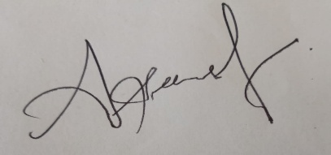
Signature of the student:

